HW3 EECS 277B Win 2010

1. For the circuit below, find the y-matrix. Next, find h21 completely. Now find h21 when rb -> 0. Now find h21 when f -> infinity. Calculate fT in this case. Find Mason’s gain U in terms of the circuit elements.

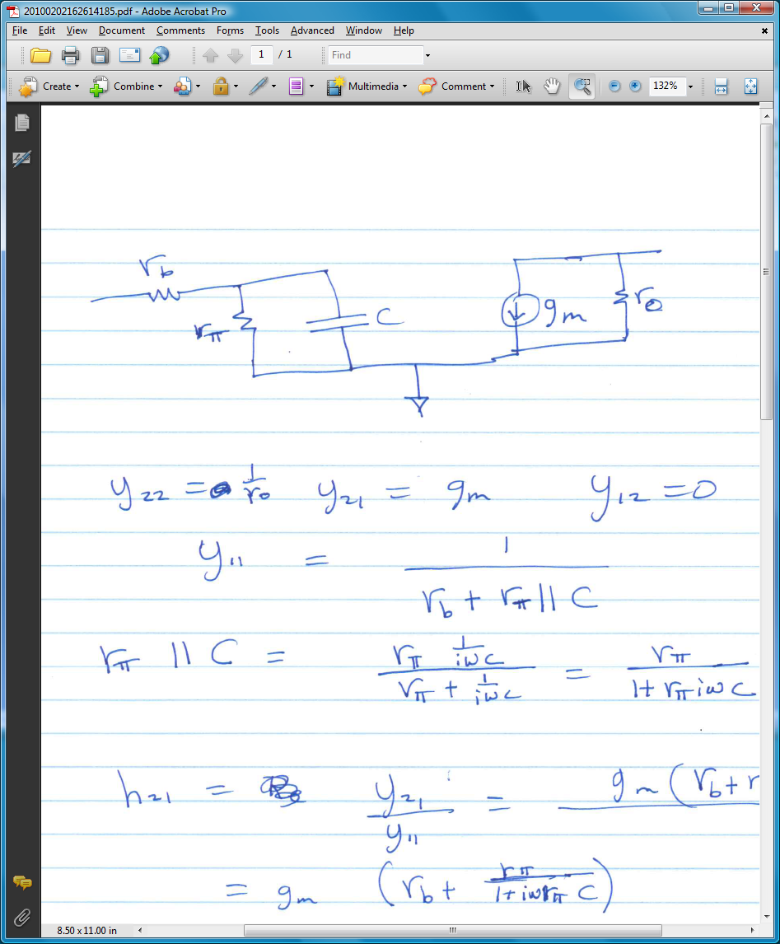

1. For the hypothetical density of electrons in the p region of an npn transistor biased in active mode, find the value of .

